1300 743 782 (SIESTA) Fax: (07) 3112 4107
reception@siestasleepandrespiratory.com.au
Dr Geoffrey Williams Provider No. 408456W
Sleep Medicine & Respiratory Physician

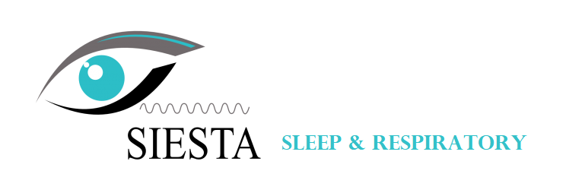
SLEEP & RESPIRATORY TESTING REQUEST FORM
STEP 1 REFERRAL FOR

SLEEP (Choose an option) → ☐ IN-CLINIC SLEEP STUDY (Level 1) ☐ HOME SLEEP STUDY (Level 2)
☐ CPAP TITRATION ☐ CPAP REASSESSMENT ☐ CPAP TRIAL
RESPIRATORY → ☐ FULL LUNG FUNCTION TESTING
STEP 2 PATIENT

☐ MALE FULL NAME
☐ FEMALE DOB CONTACT NUMBER
ADDRESS
☐ Medicare ☐ Private ☐ DVA ☐ Commercial or licensing purpose
STEP 3 LOCATION: Please note Respiratory Testing is performed at our Meadowbrook clinic only

☐ BRISBANE ☐ SUNSHINE COAST ☐ GOLD COAST ☐ TOWNSVILLE
BULK BILLING REQUIREMENTS FOR SLEEP STUDIES STEP 4: A score of ≥ 5 points + STEP 5: A score of ≥ 8 points
STEP 4 INDICATION/S

SLEEP → ☐ WITNESSED APNEA 2 points ☐ SNORING 3 points ☐ OVER 50 2 points ☐ HYPERTENSION ☐ DIABETES
☐ OBESITY (Waist: Male >102cm, Female >88cm) 3 points ☐ OTHER: _____________________________________

RESPIRATORY → CLINICAL INDICATION: ___________________________________________________________________
CURRENT TREATMENT: __________________________________________________________________
STEP 5 ESS (Epworth Sleepiness Scale): Not applicable if request form is for Respiratory Testing only

How likely is the patient to doze or fall asleep in the following situations, in contrast to feeling just tired?

⓿= No Chance
❶= Slight Chance
❷= Moderate Chance
❸= High Chance

⓿☐ ❶☐ ❷☐ ❸☐
SITTING AND READING
WATCHING TV
SITTING INACTIVE IN A PUBLIC PLACE
AS A PASSENGER IN A CAR FOR AN HOUR WITH NO BREAK
LYING DOWN IN THE AFTERNOON
SITTING AND TALKING TO SOMEONE
SITTING QUIETLY AFTER LUNCH (WITHOUT ALCOHOL)
STOPPING IN TRAFFIC FOR A FEW MINUTES WHILE DRIVING A CAR
⓿☐ ❶☐ ❷☐ ❸☐
⓿☐ ❶☐ ❷☐ ❸☐
⓿☐ ❶☐ ❷☐ ❸☐
⓿☐ ❶☐ ❷☐ ❸☐
⓿☐ ❶☐ ❷☐ ❸☐
⓿☐ ❶☐ ❷☐ ❸☐
⓿☐ ❶☐ ❷☐ ❸☐
STEP 6 REFERRING DOCTOR

FULL NAME
PRACTICE
PROVIDER NO.
SIGNATURE ____________________ DATE

STEP 7 REPORT REQUIREMENTS

☐ Urgent ☐ Medical Objects
☐ Standard ☐ Fax

Please send Request Form via FAX (07) 3112 4107 or Medical Objects
ABN 62 661 143 040

